**Unsupervised Learning**

The dataset from CC GENERAL.csv has 8950 rows and 18 columns.

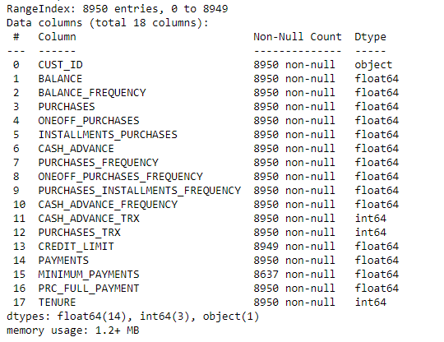

Above I have included information of the dataset. We can see that some data is missing. Below I have included count for number of values missing for each column.

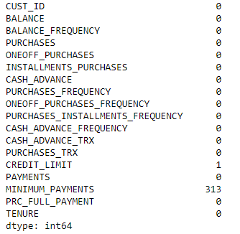

Since only 1 row has the PAYMENTS column empty, we can drop that row. For the rows missing value for MINIMUM_PAYMENTS,

* If PAYMENTS = 0, fill with 0
* Else drop row

I then drop the CUST_ID column and run K Means clustering algorithm for K ranging from 2 to 20 (not including 20). Plotting the sum of squared distances vs K we get,

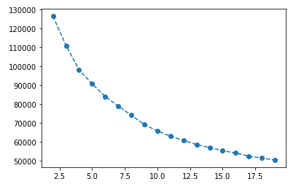

Using the elbow method, we can see that K=4 is probably a pretty good choice. I then fit the model for K = 4. I then plot the correlation of the features with the cluster labels.

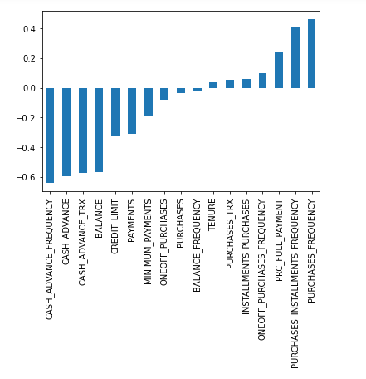

From this we can see that the features that are more negatively correlated are,

* CASH_ADVANCE_FREQUENCY
* CASH_ADVANCE
* CASH_ADVANCE_TRX
* BALANCE

And the features that are more positively correlated are,

* PURCHASES_FREQUENCY
* PURCHASES_INSTALLMENTS_FREQUENCY